23.7: a) 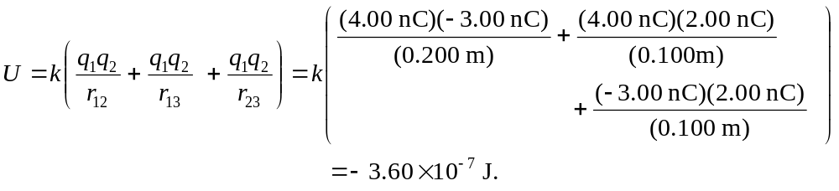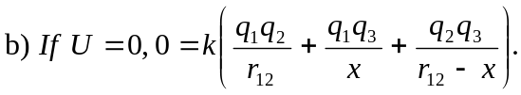 So solving for x we find:
Therefore 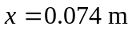since it is the only value between the two charges.

